**P6 – Configure a computer system**

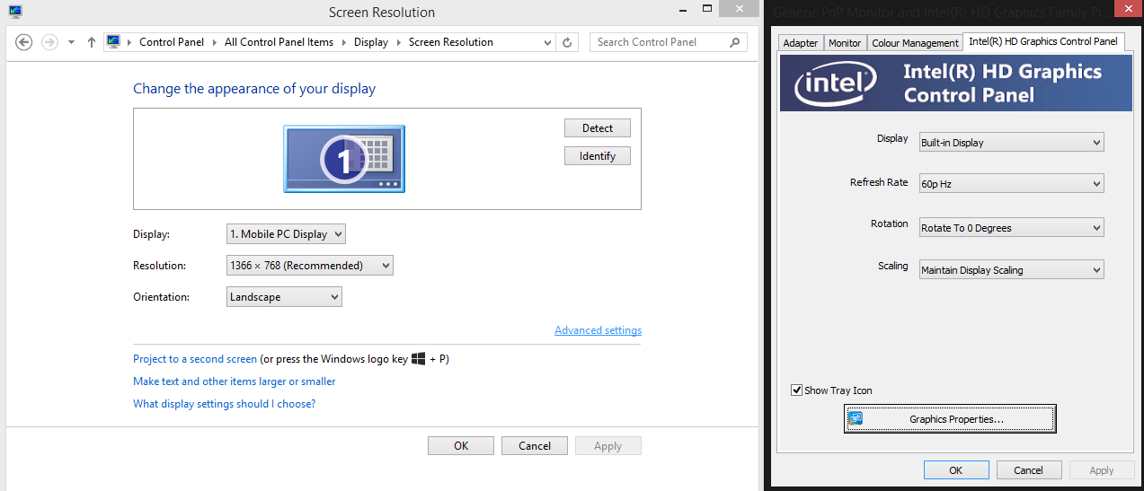

The above screenshot shows the configuration of the display settings, such as resolution and aspect ratio. I am using both Windows settings and the Intel graphics control panel.

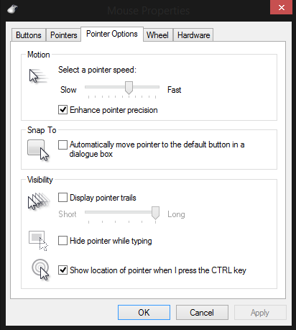

This screenshot shows the configuration of the mouse – the pointer, and how it behaves.

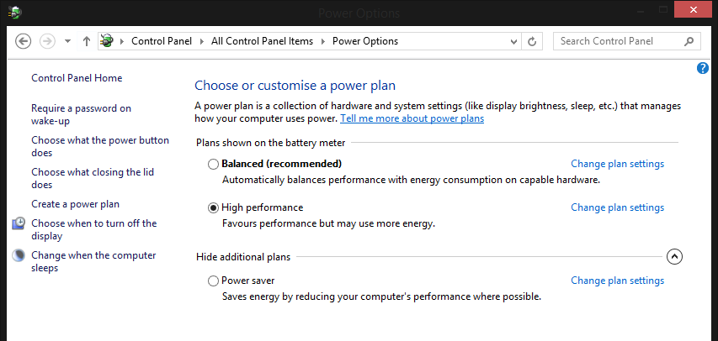

This screenshot shows the power settings. Because it is a desktop PC, it can remain in high performance mode.

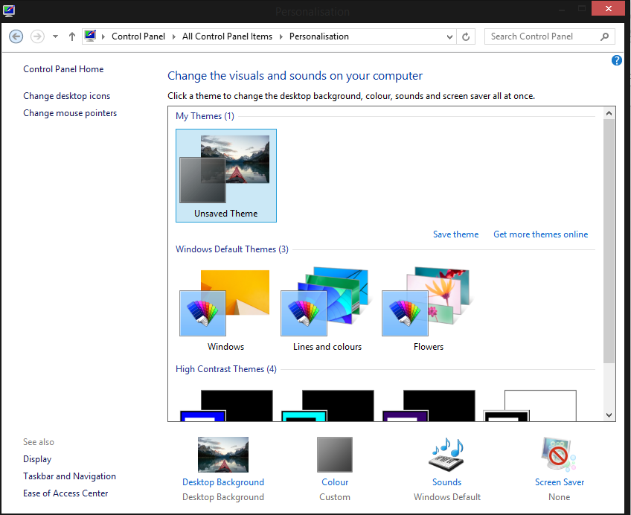

This is the personalization settings. The windows border colour has been set to black and a desktop background has been chosen.